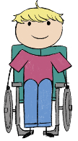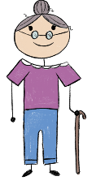

[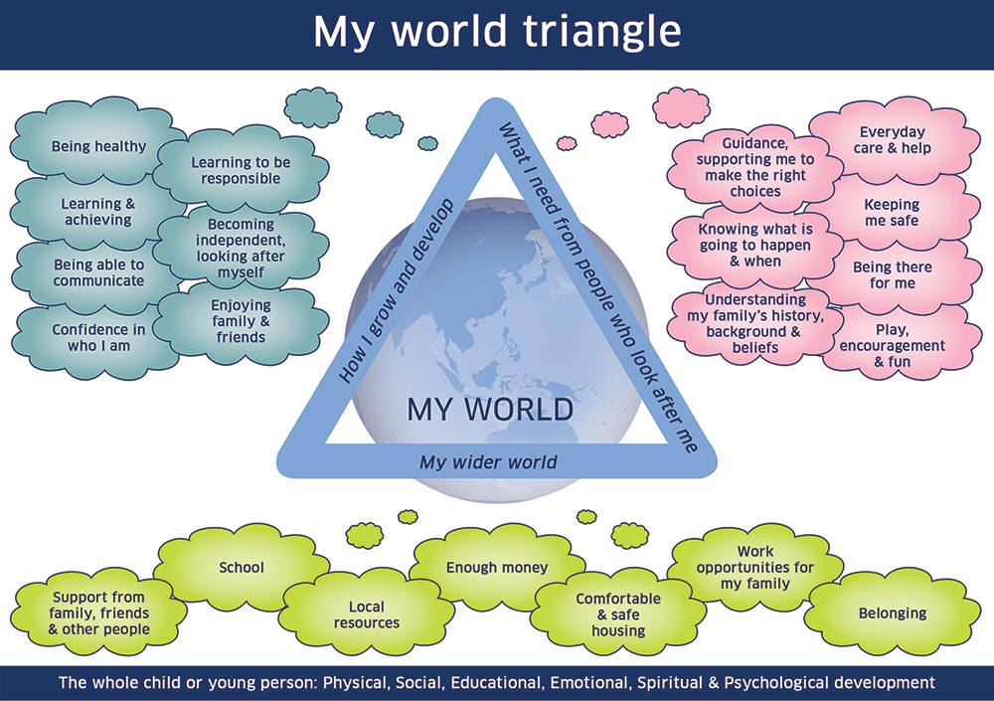](https://www.google.co.uk/url?sa=i&rct=j&q=&esrc=s&source=images&cd=&cad=rja&uact=8&ved=2ahUKEwi709LzoIvfAhUB1RoKHSGwDzsQjRx6BAgBEAU&url=https://www.careandlearningalliance.co.uk/my-world-triangle/&psig=AOvVaw0yxEJ0QHVbgDBoyTLGjXks&ust=1544187483503988)

**The reason for My** Choose an item. **Initial Plan**  **Review of plan**

|  |  |  |  |  |
| --- | --- | --- | --- | --- |
| My NameI like to be known as |  | **Parental Agreement for a plan to be opened** | | Choose an item. |
| Where I live |  | | | |
| Purpose for my plan |  | | | |
| Who called the meeting? |  | | | |
| Named Persons Service |  | **Lead Professional** |  | |

**Section 1 – My Team**

|  |  |
| --- | --- |
| **People important in my life -** The Child/Young Person should be asked who they believe are the people important in their life. This may include people outwith the family | |
| **Name** | **Relationship** |
|  |  |
|  |  |
|  |  |
|  | Press the tab key to insert another row |

|  |  |  |  |
| --- | --- | --- | --- |
| **People helping me give my voice and participate in my meeting** | | **People helping my parent/carer give their voice in my meeting** | |
| Advocate | Choose an item. | Advocate | Choose an item. |
| Interpreter / Translator | Choose an item. | Interpreter / Translator | Choose an item. |
| Other | Click or tap here to enter text. | Other | Click or tap here to enter text. |

|  |  |  |  |  |  |
| --- | --- | --- | --- | --- | --- |
| **People attending my meeting** | | | | | |
| **Name:** | **Role/ Relationship:** | **Email Address / Phone Number** | **Attended** | **Apologies** | **Update received and shared** |
|  | Choose an item. |  | Choose an item. | Choose an item. | Choose an item. |
|  | Choose an item. |  | Choose an item. | Choose an item. | Choose an item. |
|  | Choose an item. |  | Choose an item. | Choose an item. | Choose an item. |
|  | Choose an item. |  | Choose an item. | Choose an item. | Choose an item. |
|  | Choose an item. |  | Choose an item. | Choose an item. | Choose an item. |

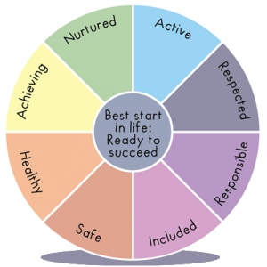

**Section 2 – Record of My Meeting**

**5 GIRFEC questions and the Wellbeing Indicators to consider throughout the meeting**

* What is getting in the way of this child or young person’s wellbeing? **The Wellbeing Indicators**
* Do I have all the information I need to help this child or young person? (SHANARRI)
* What can I do now that is needed and appropriate to help this child or young person?
* What can my agency or organisation do now to help this child or young person?
* What additional help, if any, may be needed from others?

|  |  |
| --- | --- |
| **Has there been a review of the previous action plan with incomplete actions taken forward** | Choose an item. |

|  |
| --- |
| **What are you concerned /worried about? (concerns, difficulties, challenges and risks factors)**  These views should in the child/young person’s/family’s own voice |
| **My views**  **Family views (from those who have an active part of my life)**  **Professional views (from those who have an active part of my life)** |
| **What’s going well or what has improved since the last meeting? (strengths, protective factors and exceptions)**  These views should in the child/young person’s/family’s own voice |
| **My views**  **Family views (from those who have an active part of my life)**  **Professional views (from those who have an active part of my life)** |

**Section 3 – The Action Plan to help me**

|  |  |  |  |
| --- | --- | --- | --- |
| **I am care experienced** | **I have been considered for a CSP** | **I require a CSP** | **My CSP is to be reviewed by** Click or tap to enter a date. |

|  |  |  |  |  |  |
| --- | --- | --- | --- | --- | --- |
| **Goals: How will we know things are getting better?** | **Actions - What do we need to do? (Ideas and agreed Actions (in bold))** | **Who will lead and who will help to achieve this:** | **By When:** | **Update**  **What was the outcome of the action?** | **Measuring progress** |
|  |  |  | Enter date |  | Choose an item. |
|  |  |  | Enter date |  | Choose an item. |
|  |  |  | Enter date |  | Choose an item. |
|  |  |  | Enter date |  | Choose an item. |
|  |  |  | Enter date |  | Choose an item. |

|  |
| --- |
| **My views on my plan** |
|  |
| **My Family/Carer’s views on the plan** |
|  |

|  |  |  |  |  |  |
| --- | --- | --- | --- | --- | --- |
| **Date of next meeting** | Click or tap to enter a date. | **Time** |  | **Venue** |  |
| **Date plan closed to agency** | Click or tap to enter a date. | **Name of agency** |  | **Date plan closed to all** | Click or tap to enter a date. |