






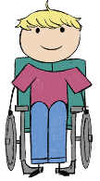






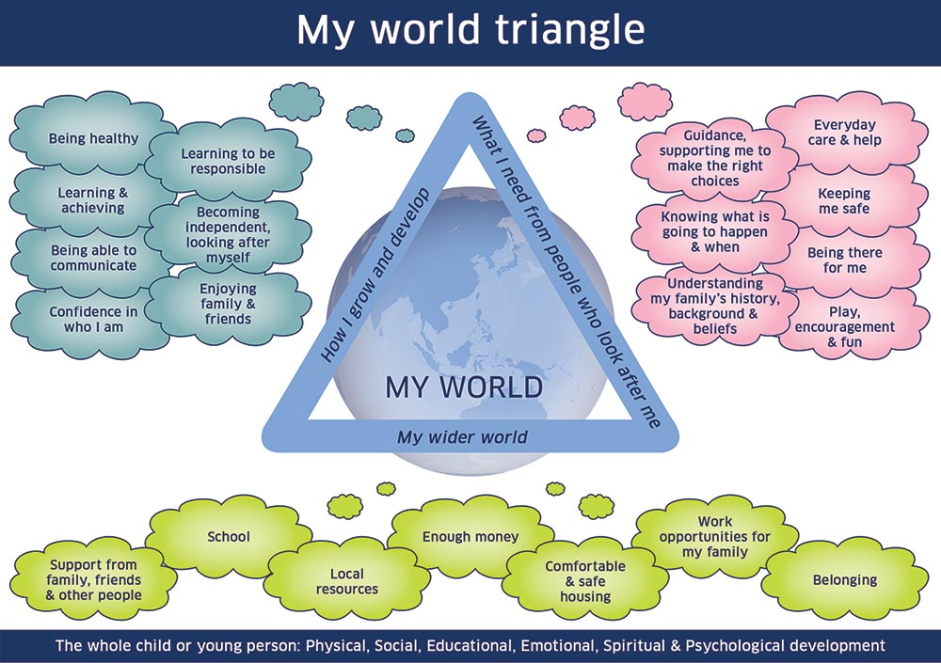

The reason for My Child's Plan Initial Plan ☐ Review of plan ☐
My Name  I like to be known as |  | Parental Agreement for a plan to be opened |  | Choose an item.

Where I live

Purpose for my plan

Who called the meeting?
Named Persons Service |  | Lead Professional | Education

Section 1 – My Team

People important in my life - The Child/Young Person should be asked who they believe are the people important in their life. This may include people outwith the family
Name | Relationship
 | Press the tab key to insert another row

People helping me give my voice and participate in my meeting |  | People helping my parent/carer give their voice in my meeting
Advocate | Choose an item. | Advocate | Choose an item.
Interpreter / Translator | N/A | Interpreter / Translator | N/A
Other | Click or tap here to enter text. | Other | Click or tap here to enter text.
People attending my meeting
Name: | Role/ Relationship: | Email Address / Phone Number | Attended | Apologies | Update received and shared
 | Choose an item. |  | Choose an item. | Choose an item. | Choose an item.
 | Choose an item. |  | Choose an item. | Choose an item. | Choose an item.
 | Choose an item. |  | Choose an item. | Choose an item. | Choose an item.
 | Choose an item. |  | Choose an item. | Choose an item. | Choose an item.
 | Choose an item. |  | Choose an item. | Choose an item. | Choose an item.

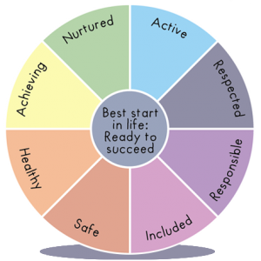

Section 2 – Record of My Meeting

5 GIRFEC questions and the Wellbeing Indicators to consider throughout the meeting
- What is getting in the way of this child or young person’s wellbeing? The Wellbeing Indicators
- Do I have all the information I need to help this child or young person? (SHANARRI)
- What can I do now that is needed and appropriate to help this child or young person?
- What can my agency or organisation do now to help this child or young person?
- What additional help, if any, may be needed from others?

Has there been a review of the previous action plan with incomplete actions taken forward | Choose an item.

What are you concerned /worried about? (concerns, difficulties, challenges and risks factors)
These views should in the child/young person’s/family’s own voice
My views

Family views (from those who have an active part of my life)

Professional views (from those who have an active part of my life)

What’s going well or what has improved since the last meeting? (strengths, protective factors and exceptions)
These views should in the child/young person’s/family’s own voice
My views

Family views (from those who have an active part of my life)

Professional views (from those who have an active part of my life)

Section 3 – The Action Plan to help me

I am care experienced ☐ | I have been considered for a CSP ☐ | I require a CSP ☐ | My CSP is to be reviewed by Click or tap to enter a date.

Goals: How will we know things are getting better? | Actions - What do we need to do? (Ideas and agreed Actions (in bold)) | Who will lead and who will help to achieve this: | By When: | Update  What was the outcome of the action? | Measuring progress
 |  |  | Enter date |  | Choose an item.
 |  |  | Enter date |  | Choose an item.
 |  |  | Enter date |  | Choose an item.
 |  |  | Enter date |  | Choose an item.
 |  |  | Enter date |  | Choose an item.
My views on my plan

My Family/Carer’s views on the plan

Date of next meeting | Click or tap to enter a date. | Time |  | Venue
Date plan closed to agency | Click or tap to enter a date. | Name of agency |  | Date plan closed to all | Click or tap to enter a date.

