Moray Locality Network Offer
This document details the offer of the Locality Network in Moray. It is intended to help services, organisations and practitioners understand what the Network is, how it supports collaborative working, and partners to engage to improve outcomes for children, young people and families across Moray.
What is the Locality Network
The Locality Network is a multi-agency group of practitioners, managers, and team leaders who work with children, young people and families. In Moray, the Networks provide a structure for collaboration across localities including Elgin, Forres, Lossiemouth (West) Buckie, Keith, Milnes, Speyside (East). Representation is organised through two locality groupings, East and West, creating opportunities to address both Moray-wide priorities and more localised issues.
The offer to partners
- The Network helps partners identify connections and find the right people to support projects, service development and emerging priorities.
- Members receive access to a weekly information which helps services stay informed and connected.
- The Network provides a source of support, information and expertise across agencies and encourages joint problem-solving.
- It creates opportunities to share successes, good practice and learning so that effective approaches can be recognised and replicated.
- It provides a route for raising themes, concerns and barriers affecting children, young people and families and for seeking wider multi-agency support.
- It strengthens understanding of the strategic picture by linking local issues and practice to wider Children’s Services Planning priorities and Health and Social Care Partnership activity
- It encourages collaboration rather than silo working, helping partners build relationships and work more effectively together.
Benefits of participating in the Network
- Participation helps services build stronger relationships with partner agencies, making it easier to work together around shared priorities, hear and act upon the voices of families, children and young people.
- It gives practitioners access to a broader range of knowledge, expertise and local intelligence, supporting more informed and joined-up responses.
- It creates opportunities to identify shared concerns early and respond collectively before issues become more rooted.
- It supports problem-solving by connecting services with partners who may be able to contribute ideas, resources or practical support.
- It provides a forum to share learning, highlight effective practice and celebrate successes, helping to spread approaches that are making a positive difference.
- It strengthens the voice of individual services and communities by ensuring local experience influences wider planning and decision-making.
- It improves awareness of what is available across Moray, reducing duplication and helping families access the right support sooner.
- It helps members stay connected to strategic developments while keeping a focus on practical, place-based action.
“Just to say I thought yesterday’s network meeting was really useful, from a network perspective but also the content was really strong, especially the input from the lived experience”
How partners engage and contribute
Partners play an important role in ensuring the Network reflects the realities of practice. Members are encouraged to provide updates about their service or organisation, share developments, and contribute intelligence about what is working well and where additional support may be required. Team Briefs are used to help members take key discussions back to their service or team, gather feedback, and support a two-way flow of information between frontline practice and the Network.
- Concerns or themes: community-based needs or trends identified by services that require broader partnership support.
- Successes: positive practice, outcomes or examples of effective support that others may learn from.
- Asks: requests for specific expertise, partners or resources to help progress a project or response.
- When raising a concern, it is helpful to include what has already been tried as a single agency, the number of children, young people or families affected, and any relevant anecdotal evidence.
- Concerns can be raised through Network meetings, by completing the relevant form, or by contacting the Locality Network team.
“It was great that they were able to present yesterday and be included in the networking aspect of working together to improve services, relationships and how we can work better”
Meeting structure and action
The Locality Network operates through a combination of Joint Network Meetings and East and West locality meetings. Joint Network Meetings are held quarterly and bring partners together in person around key themes and priorities linked to the Children’s Services Plan. These sessions provide space for networking, shared learning, discussion of emerging concerns and the sharing of good practice.
East and West meetings provide a more local, action-focused forum for discussing place-based concerns and opportunities. Where needed, concerns can lead to further focused work with the right partners, including task-and-finish groups or other collaborative activity. Not every issue requires escalation; in some cases, identifying the right relationships, resources or connections is enough to move work forward. The emphasis is on practical action, shared ownership and timely support.
Strategic links and intended impact
The Locality Network is an important link between local practice and strategic planning in Moray. It supports evidence-informed Children’s Services Planning by bringing together the experience of practitioners, the needs of communities, and the voices of children, young people and families. Through collaboration, shared learning and coordinated responses, the Network helps partners improve outcomes, identify gaps, and shape services in a way that is responsive, connected and grounded in local need.
“The Network provides a valuable space to share local issues and successes, bringing together a group with a wealth of expertise who understand local needs.
When questions arose around young people’s knowledge and confidence in relationships and sexual health, a small group of interested and supportive partners came together. The group was coordinated by the Locality Network Lead, with ongoing administrative support provided by the Network Business Support, which was hugely appreciated.
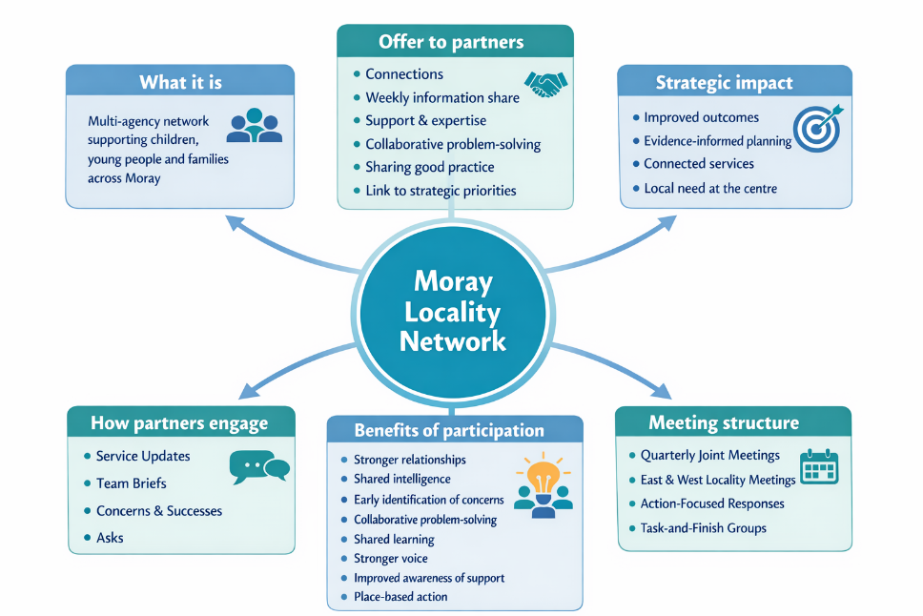
Working collaboratively, we were able to explore and respond to these questions with a small cohort of highly skilled practitioners experienced in working with young people in school settings. Throughout the process, we shared knowledge, built on each other’s strengths, and maintained close communication. There were some challenges along the way but the Network lead was there to help manage these as they arose. “

