# A colorful bird logo AI-generated content may be incorrect.Getting it Right

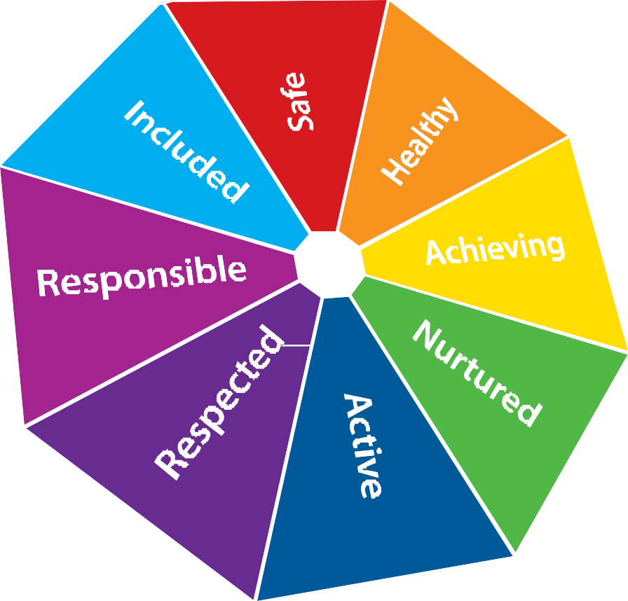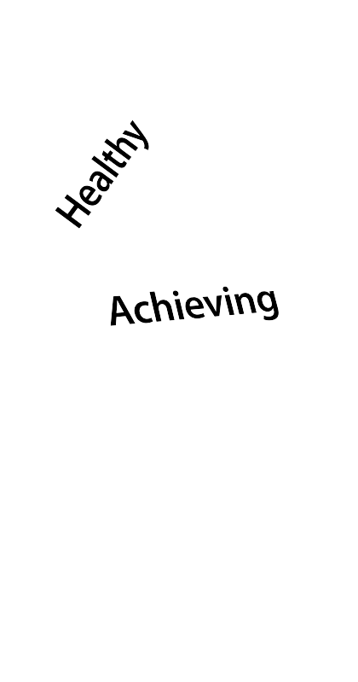

in Moray

A Guide to SMART Outcomes

Outcomes refer to the **impact** support has on a person’s life and not the outputs of services. Outcomes are the answers to the questions; ‘So, what difference has it made?’ and ‘How do we know?’ In identifying outcomes we start with a vision of positive, long-term change for children, parents, families and communities.

A guide to SMART outcomes

The most relevant long-term outcomes for children’s services are linked to the Getting It Right wellbeing indicators.

Getting It Right – Overarching Outcomes for children (SHANARRI). Every child is:

* Safe
* Healthy Click the link below :
* Achieving [Wellbeing Wheel and SHANARRI](https://www.gov.scot/binaries/content/documents/govscot/publications/factsheet/2023/05/shanarri/documents/wellbeing-wheel/wellbeing-wheel/govscot%3Adocument/GIRFEC%2BWellbeing%2BWheel%2B-%2BPDF%2B-%2B2023.pdf)
* Nurtured
* Active
* Respected
* Responsible
* Included

These are very broad outcomes. Some are long-term outcomes and are the responsibility of multiple agencies and set the context for the work with children and their families. However, whilst the work we undertake with children and their families should contribute to achieving one or more of these overall outcomes, personal outcomes are individualised to reflect the needs, priorities and aspirations of individuals.

Outcomes are set out in the Child’s Plan and are linked to the overarching SHANARRI outcomes. Personal outcomes must involve the child/young person/family, reflect their wishes about what they want to achieve and overall be specific, measurable, achievable, realistic, time-limited (SMART):

A guide to SMART outcomes continued

Outcomes in a Child’s Plan must be SMART:

* **Specific** – What exactly are we going to do? With/for whom? What is the specific outcome for the child? This must be well-defined and clear. At the end of the activities, what will have changed for the child/young person/family?
* **Measurable** – How will you know when the outcome has been achieved? How will you measure progress towards the outcome? For example through self report/Wellbeing Web/observation of behaviour, feedback/discussion etc.
* **Achievable** – Can we realistically get this done in the timeframe/within available resources? Outcomes should not be beyond the person’s or the service’s capabilities.
* **Realistic** – Is the outcome relevant and proportionate? Is it within reach and possible?
* **Time-limited** – By when do we want to achieve change? Set specific timescales for each stage and avoid the use of ‘ongoing’ and ‘ASAP’.

**Outcomes should not be too general, too vague or immeasurable**. Tools such as the Wellbeing Web can assist children, young people and their parent/carers to work together to identify the specific outcomes they want to achieve.

This guide contains some examples of SHANARRI outcomes that may feature in a Child’s Plan. The outcomes described are examples and are not meant to represent an exhaustive list.

# SAFE

* + Safe from immediate harm
  + Protected and guided by parents/carers
  + Living in a safe and secure home environment
  + Improved hygiene in the home
  + Safe from bullying in the home/school/community
  + Reduced risk of bullying/violence/drug or alcohol use/sexual exploitation
  + Protected from risk of exploitation by others (i.e. Internet)
  + Consistent and positive contact with parents/siblings/carers
  + Reduced/safer parental consumption of controlled substances
  + Protected from domestic abuse/violence
  + Reduction in/cessation of anti-social/ offending behaviour
  + Protected from anti-social/ criminal activity within the community

# HEALTHY

* + Receives a nutritious/improved diet
  + Weight is within appropriate limits
  + Parents/carers take responsibility for meeting child’s health needs, specifically…
  + Age appropriate physical development in fine and gross motor skills
  + Age appropriate language and communication skills
  + Emotional and developmental needs met
  + Independent hygiene habits established
  + Cessation of smoking/drinking/eating to excess
  + Reduced parental stress
  + Improved mental health and well-being
  + Improved family relationships
  + Ability to express feelings appropriately
  + Improved management/cessation of self harm
  + Reduction in impact of trauma/bereavement/loss

# ACHIEVING

* + Targets in IEP met
  + School attended regularly
  + Positively engaged in learning
  + Positively responds to additional support
  + Improved confidence as a learner, specifically in…
  + Plays and works co-operatively with peers
  + Follows class routines and instructions
  + Works well independently
  + Confident when faced with new challenges
  + Copes well with change (planned and unplanned)
  + Manages changes to routine and/or transitions
  + Age appropriate self care skills/independence established
  + Practical life skills developed
  + Successful transition to nursery class/primary school/secondary school/post school provision
  + Enters and sustains employment/ education/ training
  + Vocational skills acquired

# NURTURED

* + Basic needs met (food, accommodation, clothing)
  + Appropriate care and guidance from parents/carers
  + Experiences appropriate boundaries and supervision at home
  + Experiences love, emotional warmth and attachment
  + Loved and cared for by a trusted adult
  + Well developed sense of self-esteem and self-respect
  + Well developed sense of identity and belonging
  + Developmental needs understood and met by parents/carers
  + Receives additional support and care when required
  + Remains with birth family
  + Improved family routines
  + Positive contact with birth family
  + Improved knowledge of parenting/caring role
  + Improved attachment to carer
  + Improved capacity to prevent abusive/harmful behaviours

# ACTIVE

* + Explores his/her environment safely
  + Physically fit and active
  + Interests and talents developed through opportunities and encouragement
  + Positively engaged in play
  + Positively engaged in recreation/sport/activities
  + Appropriately engaged in social activities
  + Sense of achievement obtained from engagement in activities
  + Actively and appropriately involved within the family/ social network
  + Actively and appropriately involved within the school/community
  + Risks assessed and managed well

# RESPECTED

* + Parent/carer/child involved in the planning/decision making process
  + Listened to and views taken seriously
  + Works with others to resolve problems/conflict
  + Understands and accepts the consequences of his/her choices and actions
  + Trusted by/trusting of significant adults and friends
  + Does not express/experience discrimination
  + Improved family relationships and communication
  + Respects other cultures and faiths
  + Cares about and respects others
  + Regular praise and encouragement received
  + Other children’s possessions respected
  + School materials and equipment respected
  + Privacy and personal space respected
  + Consistent level of intimate/personal care provided
  + Treated with dignity and respect

# RESPONSIBLE

* Caring and considerate towards others
* Behaves responsibly at home/school/community
* Works co-operatively with other children/adults
* Understands right and wrong (appropriate to age and stage of development)
* Accepts responsibility for his/her actions/behaviour
* Understands and accepts the consequences of his/her actions
* Parental responsibility taken for child’s wellbeing
* Copes with challenges/difficulties
* Assesses and manages risks appropriately
* Makes positive choices
* Improved behaviour
* Improved communication skills
* Improved social skills
* Understands plans for his/her future (appropriate to age and stage of development)
* Takes pride in his/her personal hygiene and appearance
* Travels independently to and from school/college/other

# INCLUDED

* + Listened to and views taken seriously
  + Lives in stable accommodation suited to family size and needs
  + Lives in a well-maintained, safe and secure home environment
  + Family have enough money to live on
  + Lives safely within his/her own community
  + Accepted and valued by parents/friends and peers/ school/ community
  + Included in a positive peer group
  + Meaningful and supportive friendships established
  + Included meaningfully in class/year group
  + Improved social networks
  + Improved behaviour/ reduced exclusions

The following are **not** SMART outcomes;

## ‘Achieve full potential’ –

how will you know? how will you measure this?

* + **‘Complete wellbeing web’** – this is an action not an outcome.

## ‘Is healthy’, ‘Is safe’ –

too broad, too vague, not SMART.

This guide has been completed by staff in Moray Council with reference to ‘Wellbeing – a guide to measuring meaningful outcomes; Scottish Government 2013’ and ‘A short guide to outcomes for Barnardo’s Children’s Services; Barnardo’s 2009’.